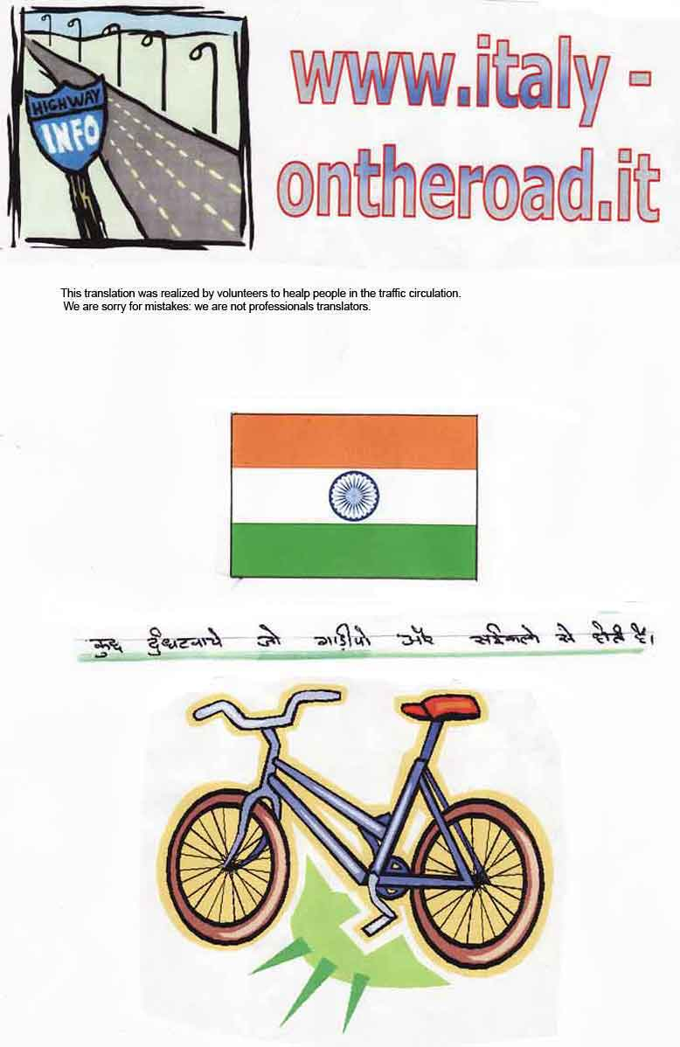
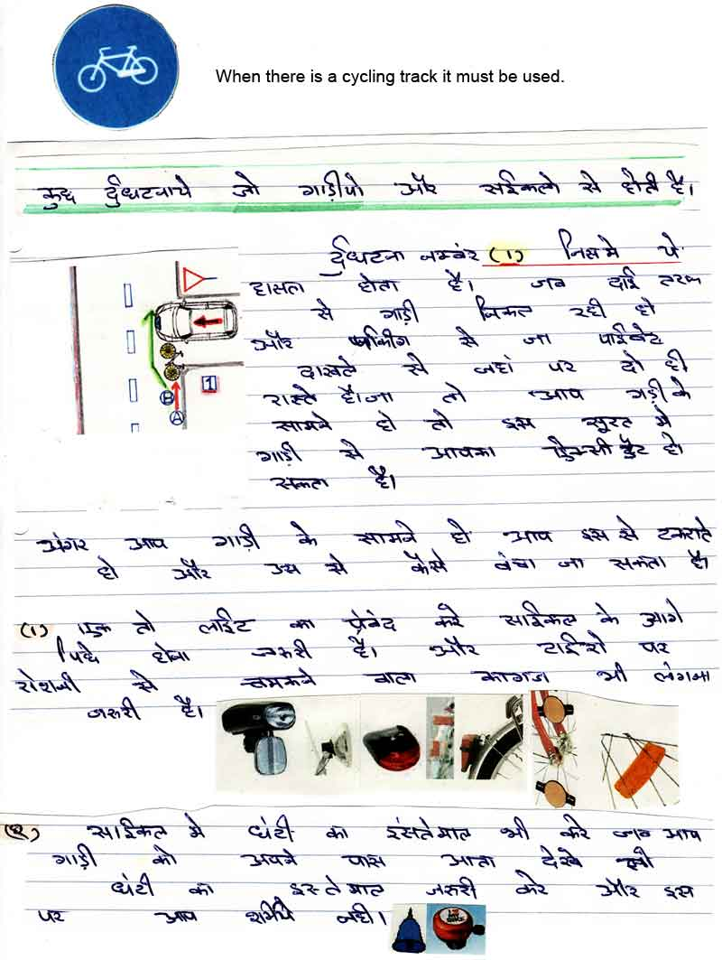

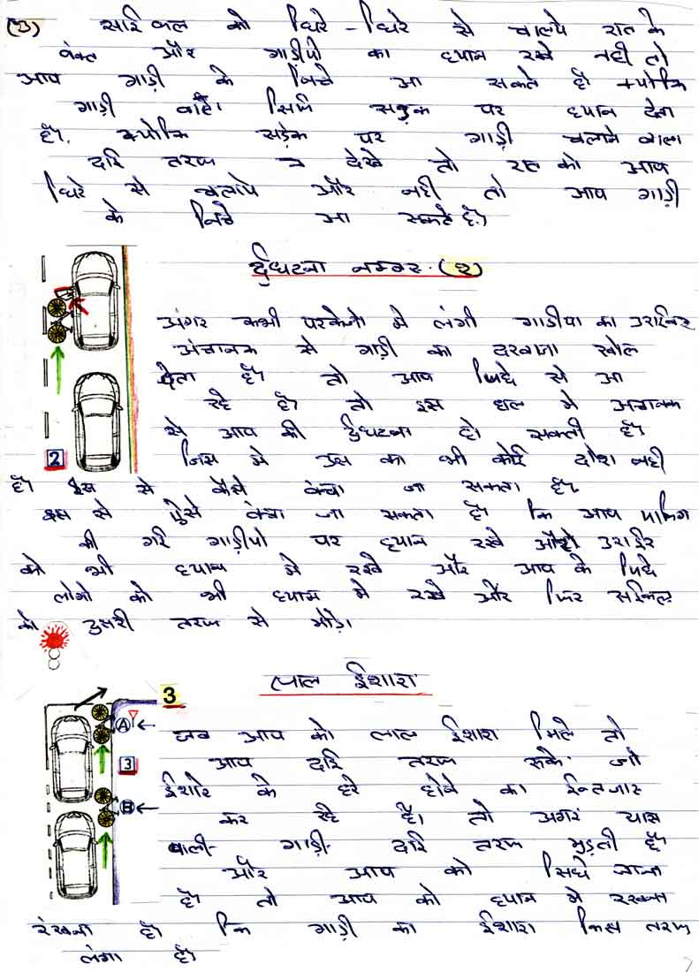
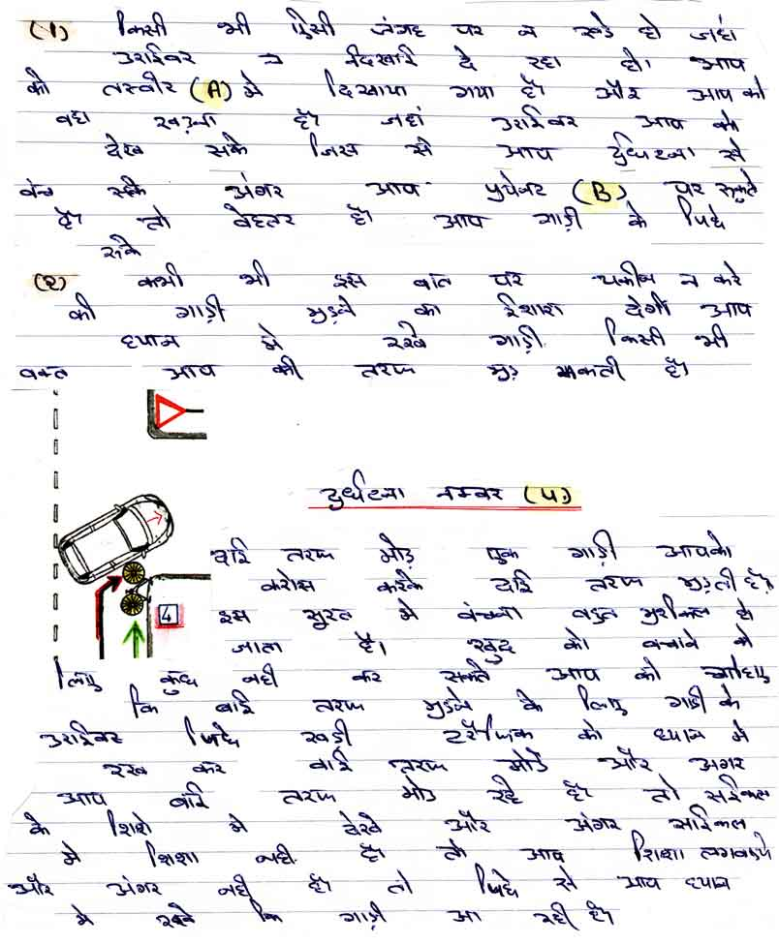

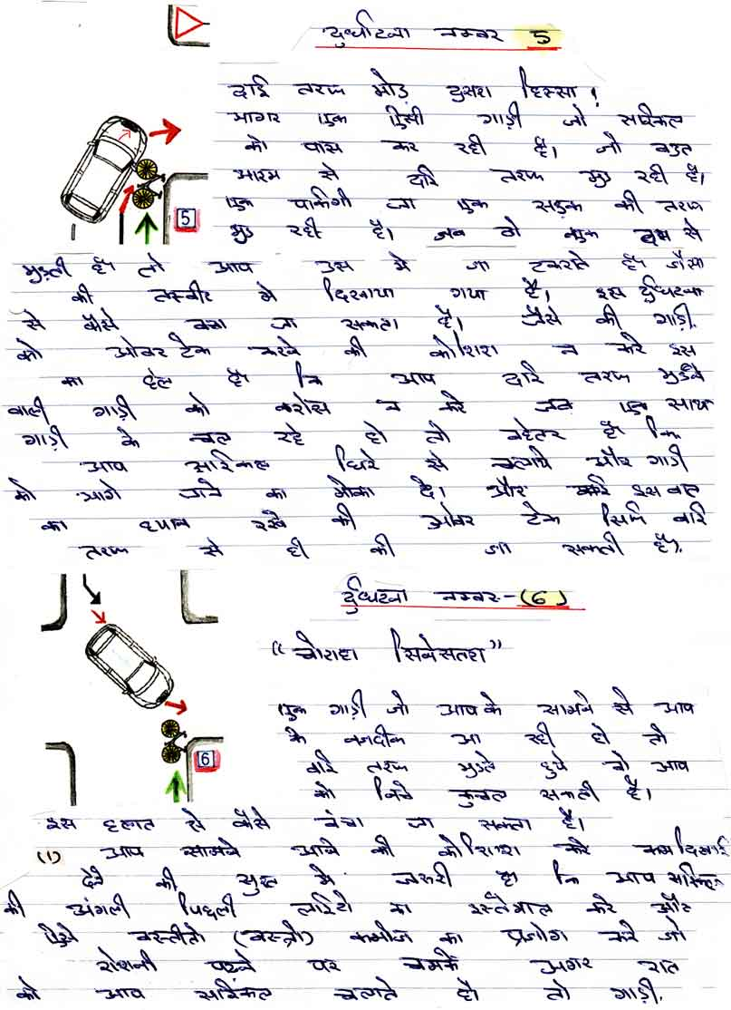

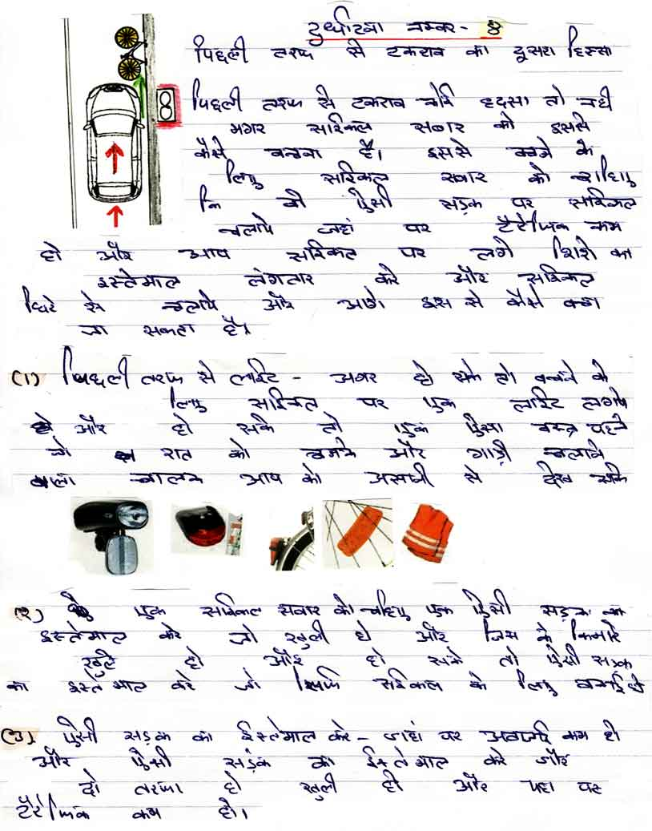

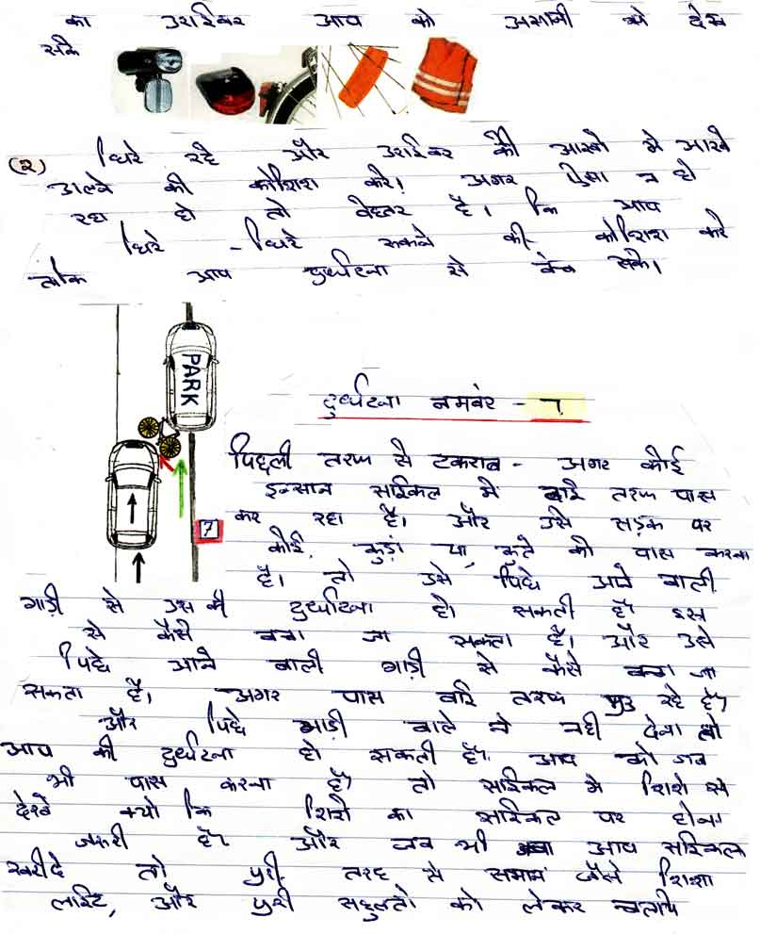

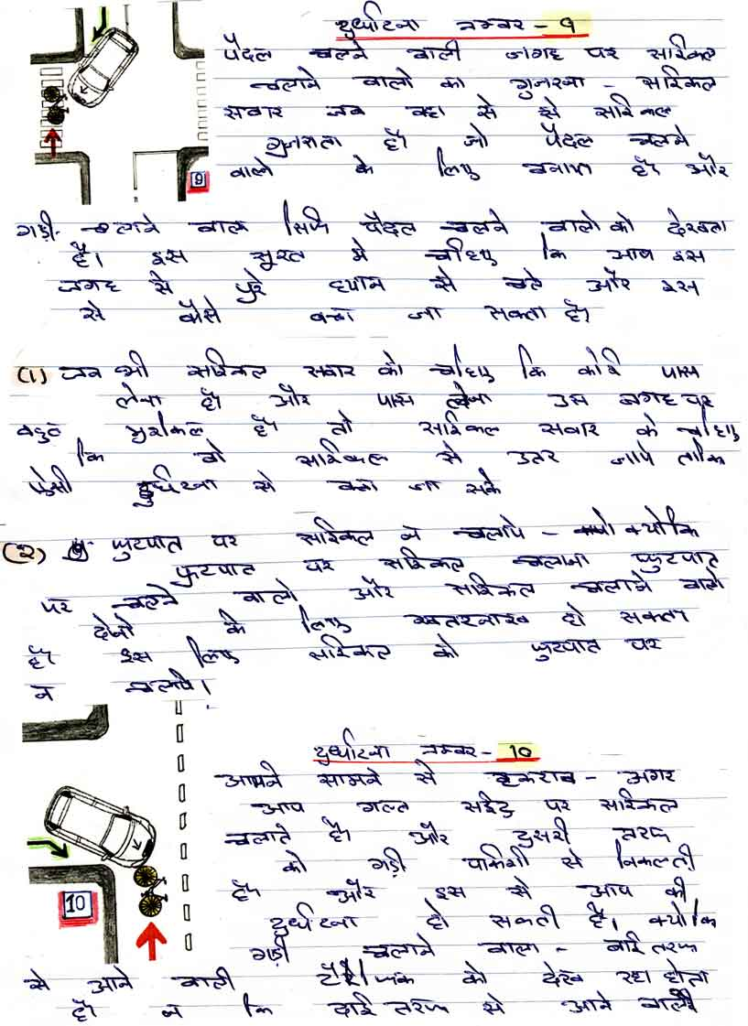

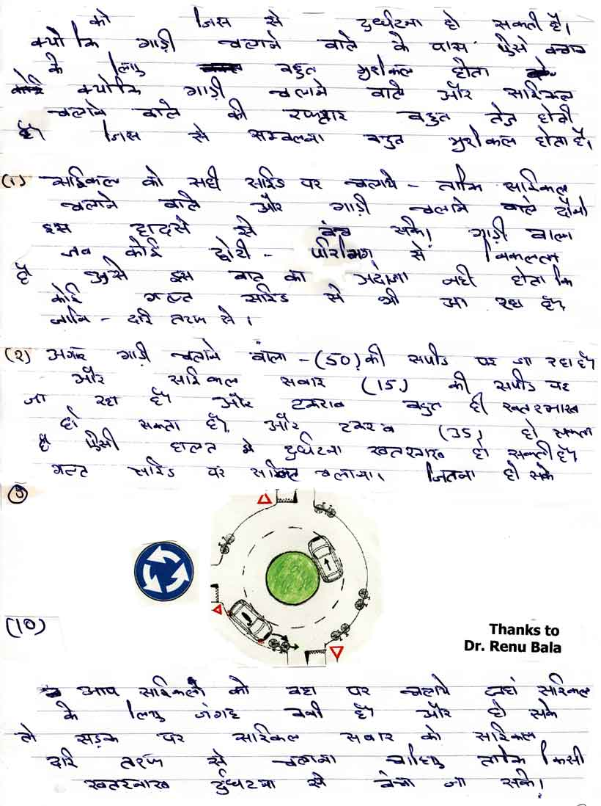

Look out for roundabout.  Bikes and moped must be much to right hand, to ring right hand. | 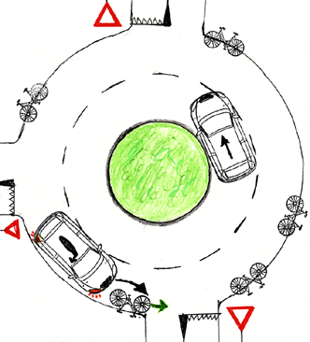

When there is a cycling track it must be used. | 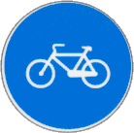

Look out for children passing.

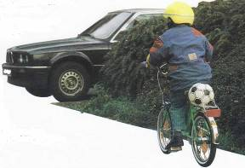 | 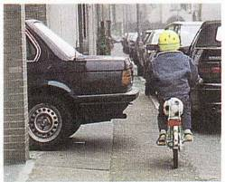

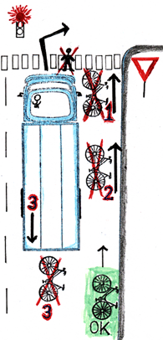 | Don’t ride at the side of lorries.  Lorry drivers are high up and on the left hand-side and they cannot see anything passing on the right hand side of the lorry:  - if a pedestrian wants to cross the road, or if you are on a bike at the side of a lorry and want to go straight on, if the lorry TURNS RIGHT he can’t see you and he will knock you over. This is even more likely if you are on your bike in the same position.  - The lorry widens his path to the left to do a right turn, whereas the pedestrian or cyclist goes straight on. NEVER STAND BESIDE A LORRY.  - Don’t stand behind the lorry: if he reverses he won’t see you and you will be knocked down.

Remember you must never stand beside a lorry: stay behind it, on the right hand side of the road/carriageway and never overtake it.

Only the most modern and costly lorries have a right side mirror added which faces downwards and allows the driver to see the lower right-hand side of the lorry (bicycle n°1), otherwise there is a blind area and the driver cannot see anything.

Only the most modern and costly lorries have acoustic devices and telecameras that allow vision behind the lorry when reversing: otherwise the driver cannot see.
Remember, that lorries, especially articulated ones or those with trailers, to turn right must widen their paths to the left, otherwise this would be impossible due to the length.
Never overtake a lorry when it is turning because the driver cannot see you and he will knock you over, even on roundabouts.

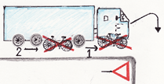

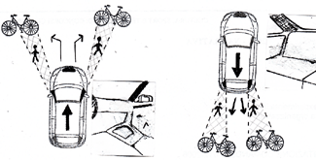 | Remember that certain parts of the chassis create blind points and reduce the visibility: creating an obstacle between you and the object in all directions: forwards and backwards, to the right and to the left.  (As shown in the diagram).

Always remember: be careful and keep your distance.

Up dated:
23 October 2007

